Green Table Extraction

- Visit the desired shoe model in stockx.com.
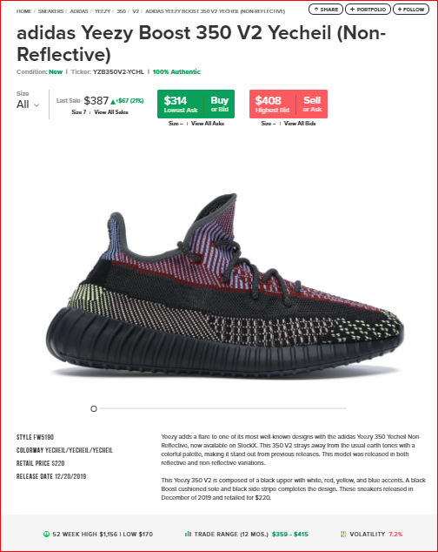

- Click on the inspect option. Then on the top right-most corner, click on the Network option.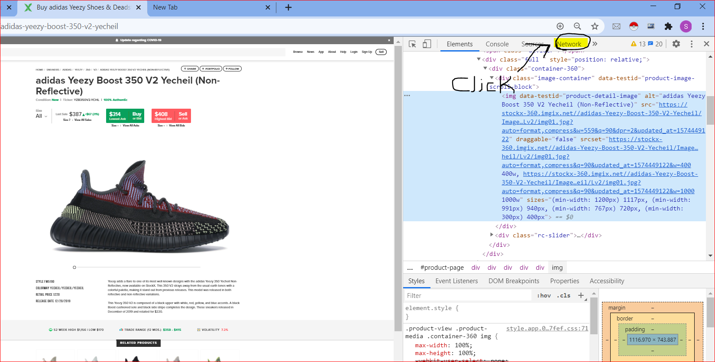
- Write Activity in Input indicated by 1st afterwards click on refresh option indicated by 2nd. You will observe a file named as activity?state….. indicated by 3rd, click on it.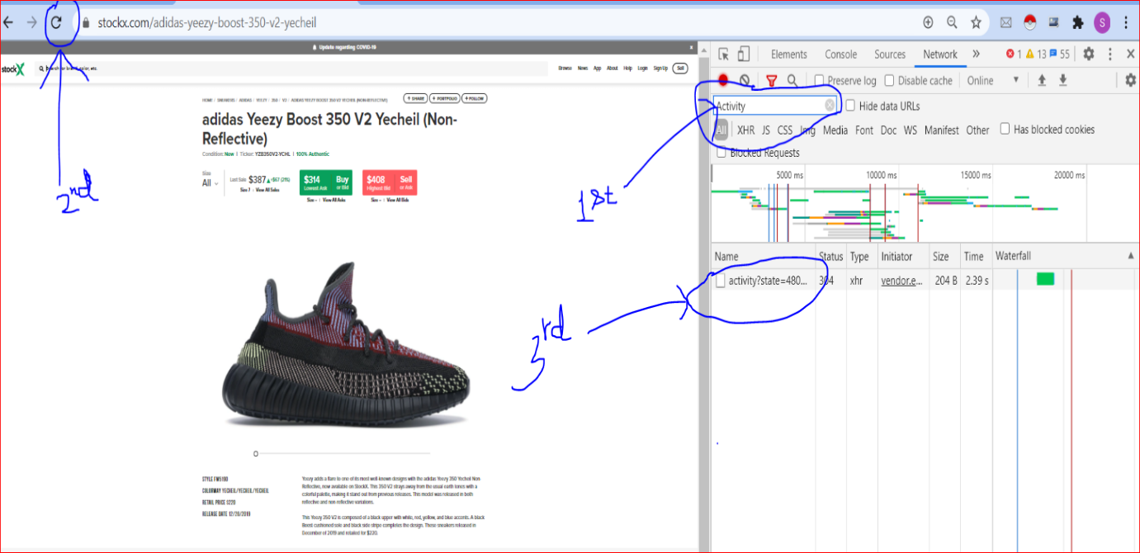
- Copy Request URL and paste it in Postman software.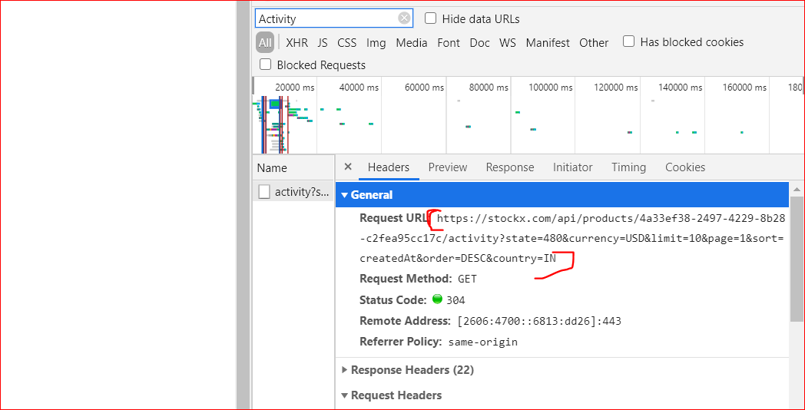
- In Postman set limit as 22000. Request method should be GET, and then send the request.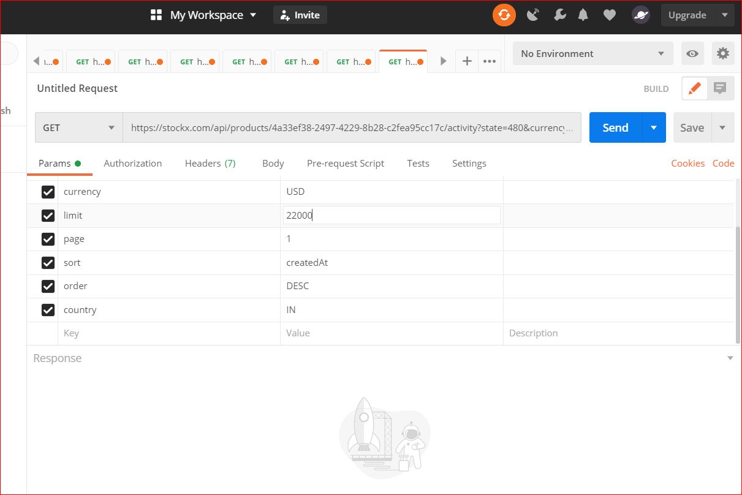
- You will get data in JSON format. Save the response.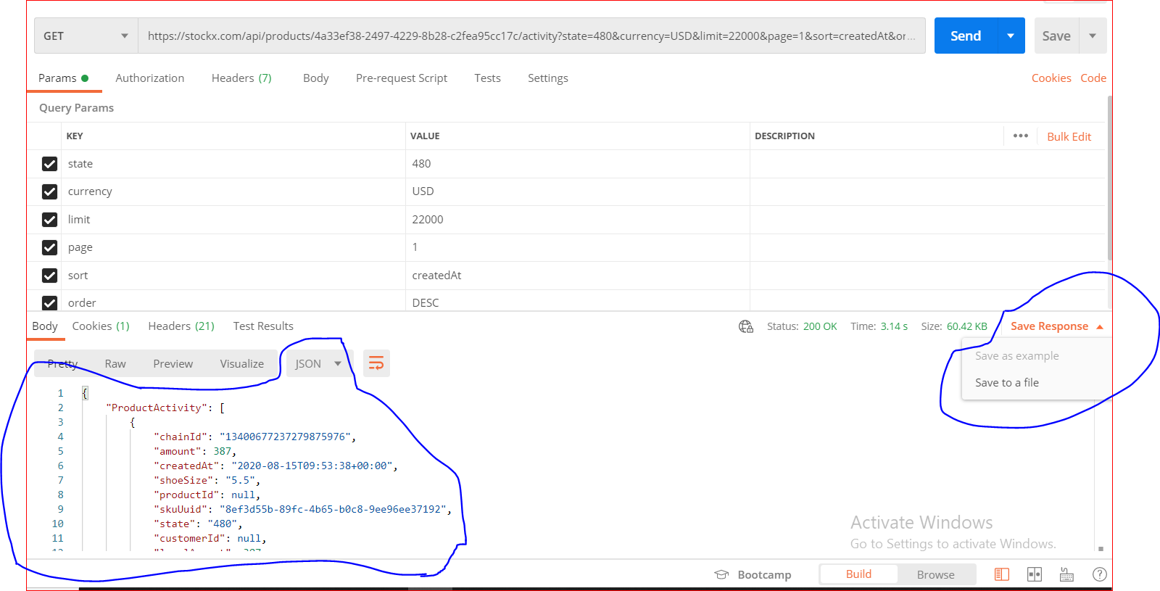
- Save the name of files as 1, 2, 3……. For the sake of simplicity and to easily interact while writing codes. And to convert the response from JSON format to CSV format, implement the given code. I have 100 files(named as 1,2,3…..100) in the folder named as green1-100 and to save converted CSV files, created a separate folder named as greencsv .

import json
import pandas as pd
for j1 in range(len("C:/Users/hp/Downloads/New foldersgoes/green1-100")):
# suppose error accour at 30 then write j1=j1+30 or j1=j1+31
j1=j1+1
print(j1)
print("\n")
pathjson = "C:/Users/hp/Downloads/New foldersgoes/green1-100/" + str(j1)
pathcsv = "C:/Users/hp/Downloads/New foldersgoes/greencsv/" + str(j1)+".csv"
myjsonfile = open(pathjson, 'r')
jsondata = myjsonfile.read()
obj13 = json.loads(jsondata)

list = obj13['ProductActivity']

df = pd.DataFrame(list)
print(df)
df.to_csv(pathcsv)

